Dataset Analysis using SQL workbench

Dataset -1 [IPL_data]

- Create table
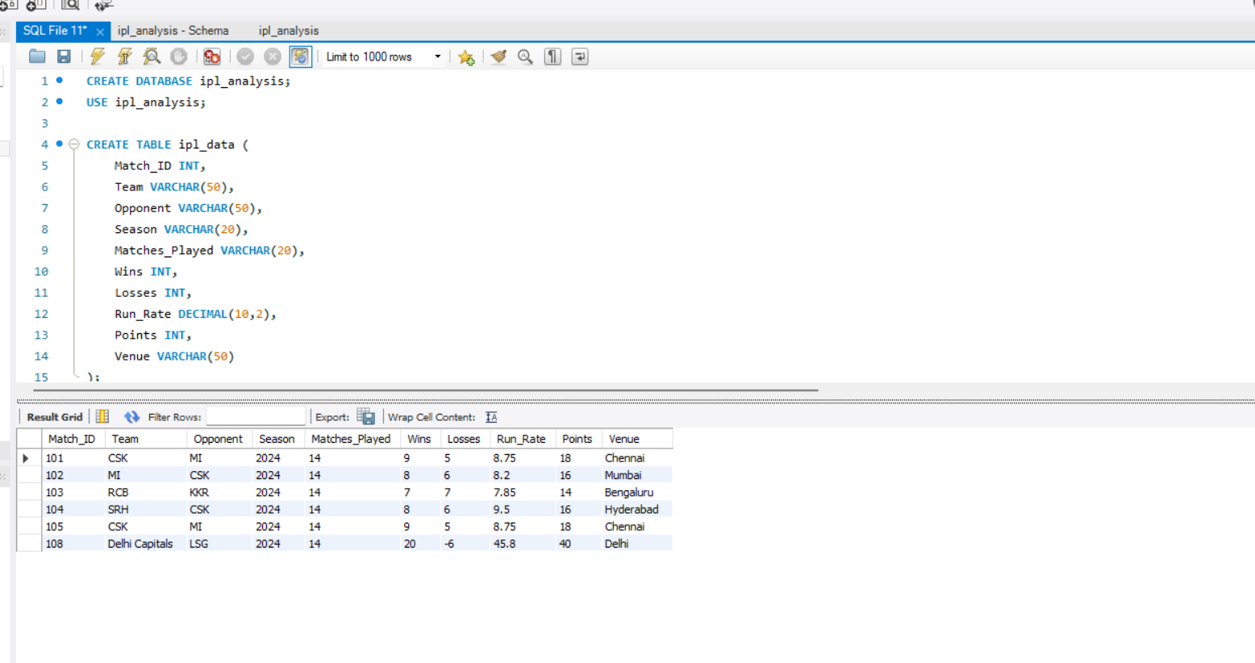

1.Rank teams by points

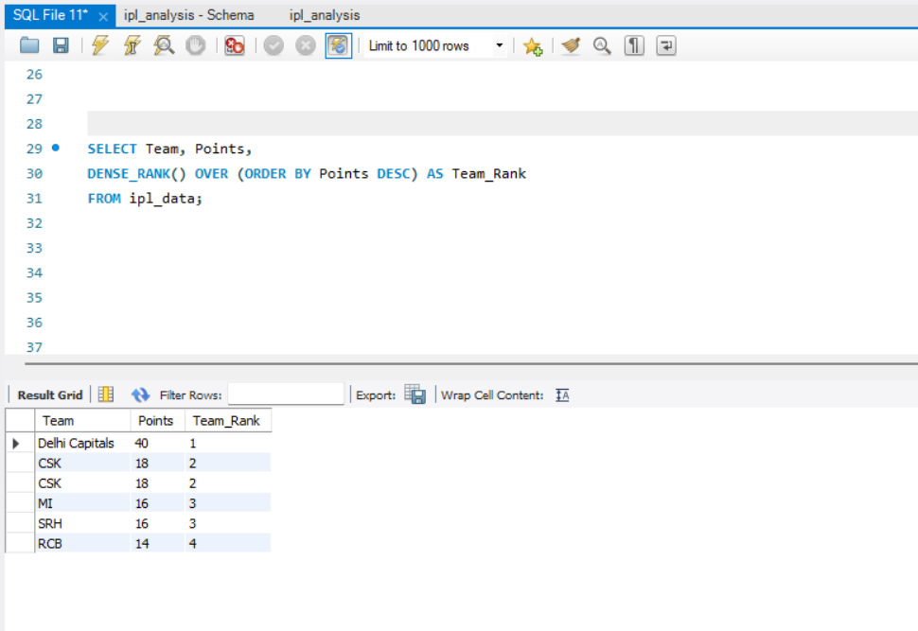

2. Calculate win percentage
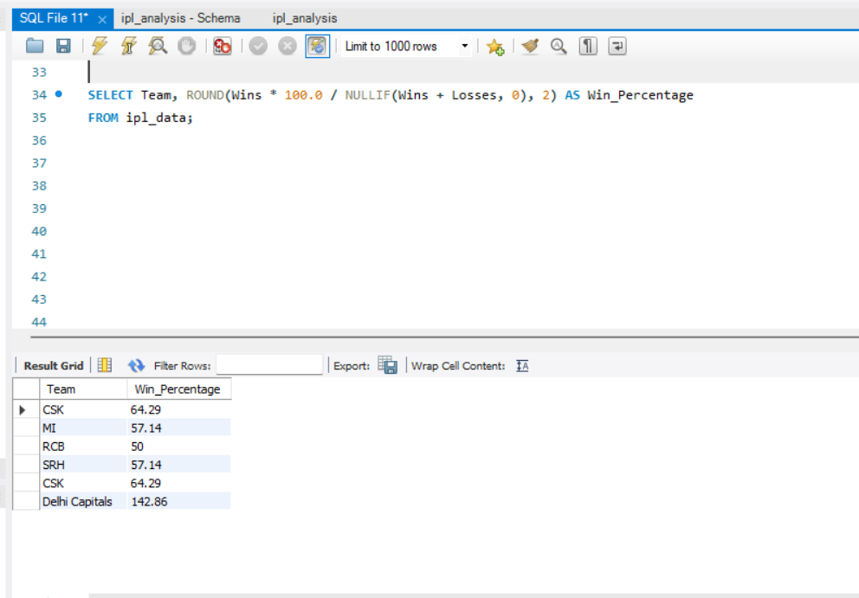

3. Find teams with above-average run rate
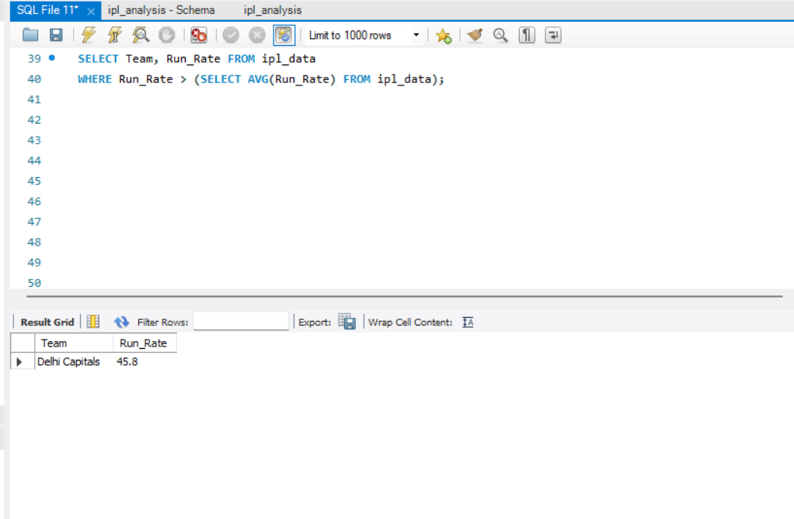

4. Find teams with above-average points
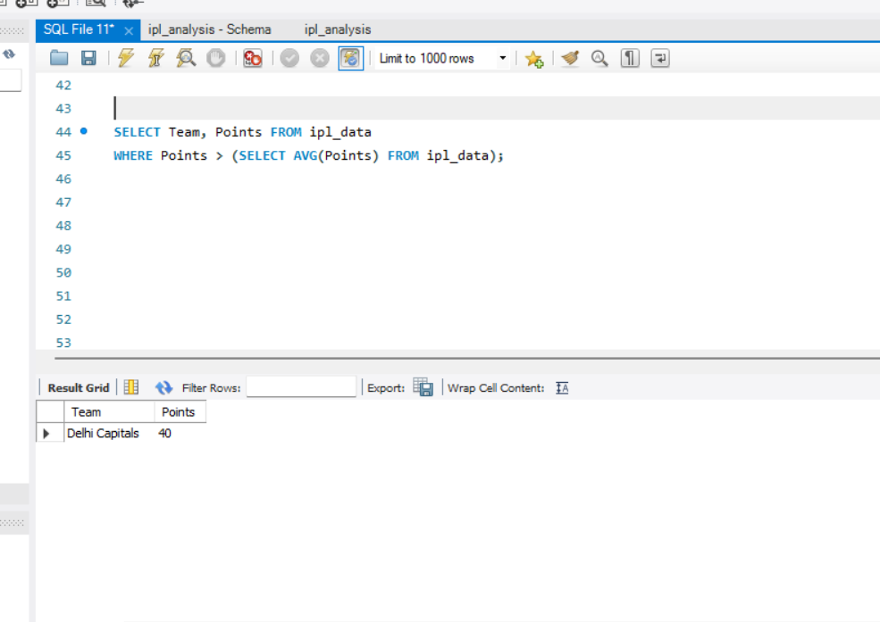

5. Find the top 3 teams by wins
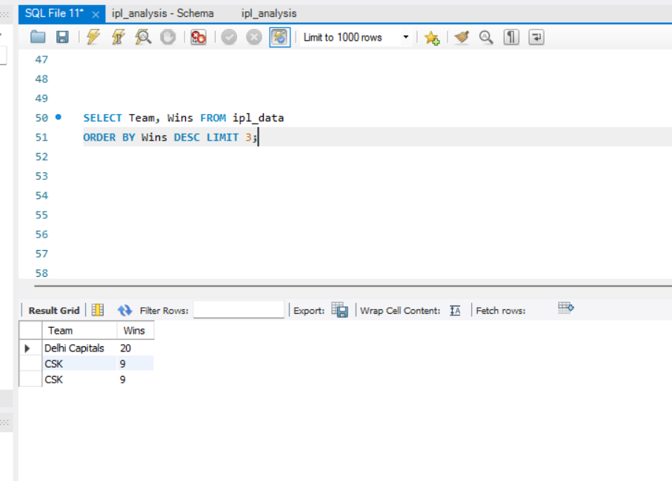
6. Categorize team performance
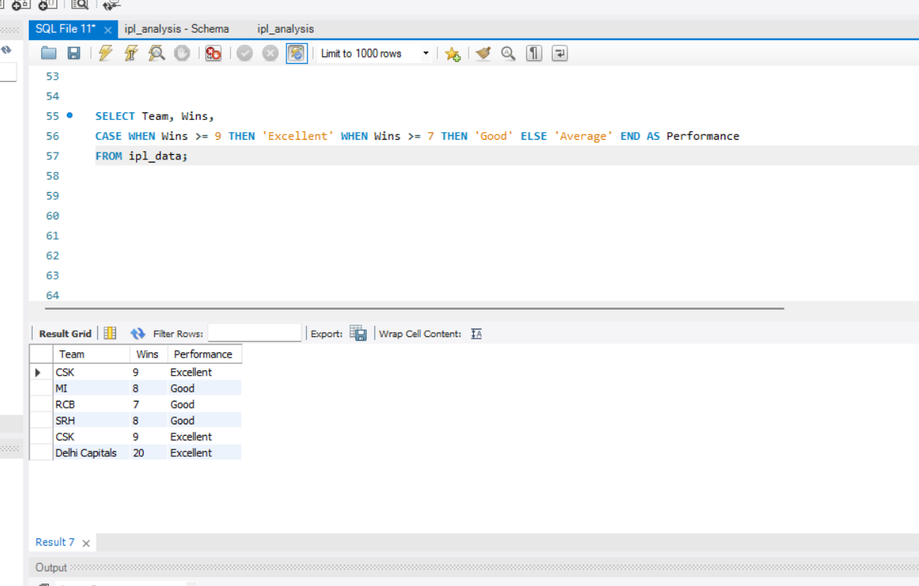

7. Find teams with unusually high run rates
